Social and Professional Issues

Tutorial 9



In my opinion, the term “the ethical point of view” means

* How we deal with things or actions with the principle of morality, not from our own perspectives and interests only but take into consideration others’ as well.
* We respect our own goals and achievements but also have to be considerate of others’ goals.



**Kantianism**

* Kantianism is a concept of someone that has the desire to do something good out of their own will and motivation.
* Kantianism encourages people to cultivate the desire to do the right things.
* Eg. Someone helping an old woman crossing the road is out of their own will instead of for any benefits.

**Utilitarianism**

* In utilitarianism, the way to judge an action whether it was good or bad depends on the outcome of it.
* If the action outcome benefits someone then it will be defined as good, if it harms someone then it would be defined as bad.
* Eg. If today someone saved 5 people from a fire accident instead of 1 person from another accident, it would be considered as a good outcome because 5 people have survived instead of one person.



Act utilitarianism believes that whenever we are deciding what to do, we should perform the action that will create the greatest net utility. In their view, this principle will produce the best overall result and it should be applied on a case by case basis. The right action in any situation is the one that yields more utility (i.e. creates more well-being) than other available actions.

Rule utilitarians adopt a two part view that stresses the importance of moral rules. According to rule utilitarianism, a specific action is morally justified if it conforms to a justified moral rule; and a moral rule is justified if its inclusion into our moral code would create more utility than other possible rules. According to this perspective, we should judge the morality of individual actions by reference to general moral rules, and we should judge particular moral rules by seeing whether their acceptance into our moral code would produce more well-being than other possible rules.

Similarity of rule based utilitarianism and act based utilitarianism: both focus on “consequences /outcome” of your action/decision/move -e.g. decision /action that promotes greatest happiness over/across majority people will be ethical...

Difference:

Act Utilitarianism

● It is a concept that believes morality of an action is determined by its usefulness to most of the people so that it brings greatest good or happiness to the greatest number of people.

● --> An action becomes morally right when it produces the greatest good for the greatest number of people.

Rule Utilitarianism

● It is a concept that believes an action can be morally right if it conforms to the rules that will lead to the greatest good or happiness to the majority of people.

● → Correctness of an action is determined by the correctness of its rules and that if the correct rule is followed, the greatest / maximum good or happiness is achieved.

Case:

Assume that you are now driving and stop at a T-junction with traffic light system working well & with a red light on and there is no car/pedestrian around and it is now midnight 2am.

(i) Propose and justify your move/act/decision made under **act-based utilitarianism.**

Since there are no cars or pedestrians around, I will continue driving in order to reach my destination faster and at the same time no one is hurt/injured.

(ii)Propose and justify your move/act/decision made under **rule-based utilitarianism.**

I will not continue driving as running the red light is against the traffic rule, although there is no car and pedestrian at that time.

Under rule based utilitarianism, i will first ensure myself to adopt to the right rules (red light on- stop, green light- proceed on/cross the road, yellow light- ready to stop). By adopting this rules, it will ensures greatest benefits to majority people (e.g. no accident will happen/ no body get hurt/injures, driver won’t be caught under speed trap camera/ AES.

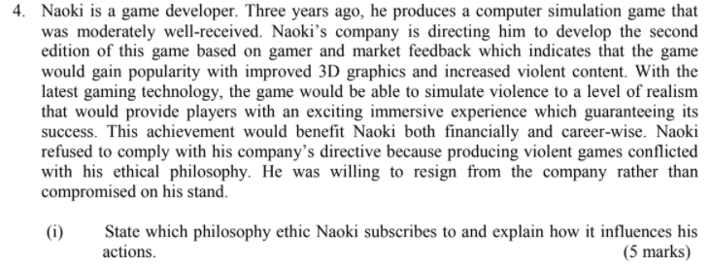

The philosophy ethic Naoki subscribes is **subjective relativism**. This is because, each person decides right and wrong for himself or herself.

In this case, Naoki thinks that making violants games contradicts his moral philosophy. Meaning to say, from Naoki point of point, the act to continue to develop/work on violent games is not ethical as although developing a more violent game can bring many benefits to him (in terms of financial rewards, or better/higher career path, he would rather resign from the company because he thinks that developing a violent game is not right and will harm the society (e.g.players may gain exciting immersive experience - . As he may think that the game experience is too violence and should not be improved in this way. It may bring some bad influences to the player-à groom children mind set to be more violent/aggressive oriented, those that used to release anger through virtual game environment may inherit it to the real world, increase family/child abuse/violent case .)

In this case, the Games development house (e.g. Naoki’s company) will think that it is ethical to continue to work on this type of violent games as They might think that the level of realism is to allow the player to have a better experiences in the game. So they will continue to run that project. In this case, it would be ethical to embed in violence element to the video games as Naoki may find that it is ethical to do so since it meets the demands of the market, increase sales of the company, strengthen games developer and the company reputation, lead to financial rewards to games developer and fulfill the player desire to play such games. Meanwhile for the games house, the act to continue to develop/work on violent games is ethical

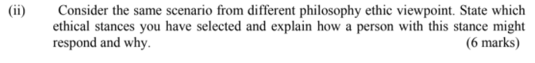

The ethical stances I have selected is act based utilitarianism.This is because,utilitarianism actions are judged rights or wrong solely by their consequences.

List of benefits:

-A person will think that producing violents games can provide players exciting immersive experience

-meet market demands would bring financial to the company.

List of drawback:

-It may bring some bad influences to the player--> groom children mind set to be more violent/aggressive oriented-imposed parental guide control for those under-age children (e.g. below 18 years old )

In view of the above, benefits outweigh drawbacks-->in this case, it is ethical

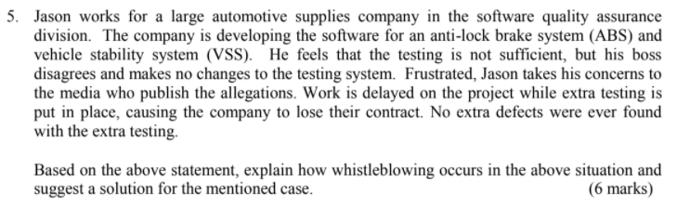

Whistle-blow: the act of disclosing of the suspected wrong-doing / inappropriate/illegal measure that taken by a organization to reach out to public.  
Jason became a whistle-blower because he wanted to confirm the ABS system and VSS system are completely safe before the public use so he discussed it with his boss but his boss disagreed with his point and made no changes to the testing system.

Solution:

Before Jason reported such suspected wrong doing to public, Jason should consider the following factors:

1.Has Jason told his manager?

2.Is Jason sure of whistleblowing work?

3.Have Jason tried every possible action?

4.Does Jason have persuasive documented evidence?

5.Will company action and decision harm to the public?

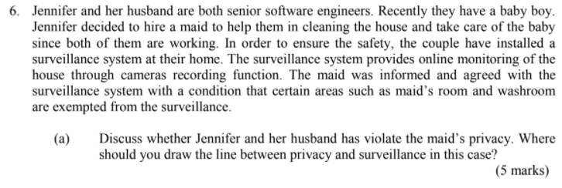

Jennifer and her husband did not violate the privacy of the maid, because when Jennifer and her husband were not at home, they had to make sure the maid did nothing wrong at home. Whether for the sake of protecting their own money, Jennifer's children or paying close attention to her job, the owner has the right to monitor the maid with her permission under certain conditions, but they have no right to monitor the maid's room and the bathroom.



It refers to an ethical theory that advocates directly using behavior effects to determine whether behavior is justified or not. It is because Jennifer and the maid are in different situations. Jennifer's behavior is difficult to judge as moral. Jennifer chose this behavior because of her own situation. Because Jennifer wants to keep her house safe.

List of benefits to put maid under surveillance:

-The safety of the baby can be ensured.

-Can monitor the maid is not stealing anything from the house.

-Baby and maid current situation can be handled by Jennifer and her husband.

-used as proof/evidence to defend maid/owner legal charge

-if maid fall unconscious, jeniffer can call for help on time

List of drawbacks to put maid under surveillance:

-The maid is not feel free/comfortable because her actions are always monitored by someone.

-Jeniffer may lose focus on her work because pay too much attention to her of monitoring of the maid during the working hours

In view of the above, the act of Jennifer is bringing more benefits than drawbacks, i think that the act of jennifer is ethical.

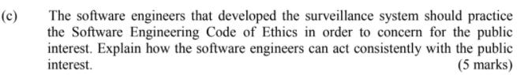

1. Take full responsibility for your own job.
2. Be fair and avoid deceiving others in all statements about software or related documents, methods and tools
3. Consider any situation which may reduce the acquisition of software benefit

· Accept full responsibility for own work. If there is any harm done by the CCTV system, the software engineer that developed the CCTV should bear the responsibility.

· Balance competing interests. If there is a conflict between profits and public interest (safety), engineer should reduce the harms.

· Approve software only if it is safe. If it is not safe, change and test the system again.

· Disclose actual/potential dangers. If the surveillance system can be easily hacked by others and to gain private information, public should be aware of it and take precautions steps.

· “Cooperate in efforts to address” public concerns. Software engineers should consult whoever that is expert in surveillance system in producing a product that best serve the public.

· “Be fair and avoid deception in all statements”. Software engineer should reveal all the strengths and weaknesses of the system when launching to the public.

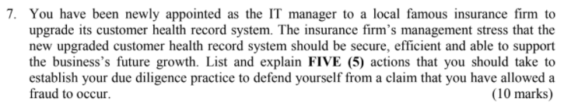

1. Good attitude

I need to make sure that I have the right and good attitude, such as a sense of responsibility, and that I and my team members have received adequate training in the project. If it is not my area of expertise, obtain advice from consultants or lawyers who specialize regarding the health issues.

1. System logs

I should implement a system to keep logs of usages in the system, and check them regularly to ensure that sequential attacks were identified. This is to ensure that attacks to the system are identified and dealt with appropriately, and to plan for further security measures to be implemented to the system to deter future attacks.

1. Confidentiality

I should keep the confidential information about the system to myself, and not reveal them to anyone who is not directly involved with the implementation. Besides, I also should maintain confidentiality of customer and company information and ensure that the system is only available to authorized persons. In addition, information should not be disclosed to other unrelated persons.

1. System testing

I should make sure the system has enough tests, such as safety tests and so on, and analyze it to ensure the efficiency of the system. Besides the test is also to ensure that the system has sufficient security measures in place to prevent fraud from occurring.

1. Place requirement clauses in contracts.

Negotiating requirements into contracts, such as product samples or analysis, insurance, currency, certification, and compliance or regulatory documentation is an effective measure to ensure you are dealing with legitimate parties.

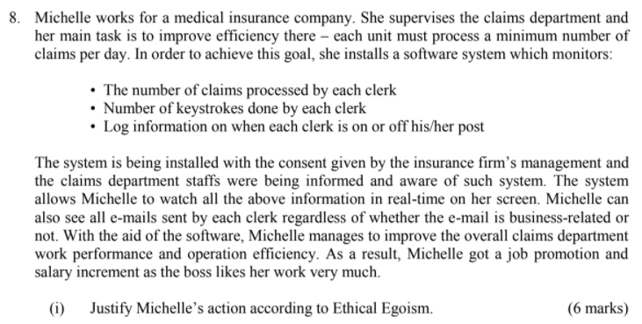 According to ethical egoism, it defines each person should be mainly focusing only to act in your self-interest or your target to obtain the maximum long-term benefit for yourself. For example, Michelle, as a supervisor, meets the needs of the company and improves the efficiency of the claims department, which shows that the claims department only pays attention to its own responsibilities, and finally she rewards promotion as the greatest long-term benefit.



Principle:Each person decides right and wrong for himself or herself.”What’s right for you may not be right for me.”With subjective relativism the line between doing what you think is right and doing what you want to do is not sharply drawn.

In this case,Michelle might say:”Since I am hired by the medical insurance company to improve the overall claims department work performance and operation efficiency,I know it’s not right to invade privacy of others with the use of surveillance software,but I will justify and said it is right for me to closely monitor the claims department staffs”work done and email sent with the use of workplace surveillance software in order to improve the overall claims department work performance and operational efficiency or else I can’t complete those missions/tasks assigned to me.”

In this case,the claim department staffs might said “Each of us should entitled for basic human right,Privacy right-to free from surveillance/observed by other or free from outside intrusion.So it is not right for Michelle/management to closely check/scan all emails sent by staff regardless of whether the e-mail is business-related or not with the use of workplace surveillance software”

Hence,under subjective relativism,we cannot say that both of them are right or wrong.Therefore,there is no moral distinction.